McKillop Library’s key accomplishments for 2021-2022 include:

* Support of the library renovation project with significant progress on the deaccessioning project.
* Successful searches and onboarding of two new team members.
* Cross-campus collaboration on special events including the Inclusive Reading Club and the Mercy Critical Concerns Faculty Collaboratives.
* Special programs collaboration with faculty to showcase student work in the library.
* Support of Salve’s 75th anniversary kick-off.
* Increased access to the institution’s history through digitization of materials from the archives.
* Continued monitoring of the library’s budget lines and use of e-resources to identify materials for cancellation in favor of new resources to support the curriculum.
* Hosting a visiting scholar from Universite Catholique de Lyon, Elvira Peyraud in a cultural and scholarly exchange.
* Support of successful accreditations: CCNE (nursing), RIDE (education), CACREP (counseling).
* Launched new digital scholarship project: [Salve Regina Sentinel Trees](https://salvereginatrees.omeka.net/) with Jim Chace.
* Support of two digital scholarship interns (art department, Nature Cabinet, and biology department, Sentinel Trees).

The library team made significant progress in 2021-2022 goals.

2021-2022 goals

* Work with campus facilities and other departments to create a “*learning commons* “and shift the library culture from a traditional venue to a hub of student engagement. Please see section, “Support of Renovation Project.”
* Continue to meet the ongoing faculty needs for instructional support. Please see section, “Research and Information Literacy Instruction.”

2022-2023 goals:

* Make significant progress in weeding the main collection.
* Support renovation planning and implementation efforts.
* Integrate new hires into the library and Salve community.
* Continue to make the library a welcoming place to all members of the Salve community.
* Continue to strengthen relationships with academic support units.
* Support Core Curriculum Structuring Committee work.
* Continue to build on last year's digital scholarship work.
* Update or create library policies where necessary.

**Library Renovation**

*Deaccessioning Project*: Upon learning of plans to renovate the library and after receiving funding to subscribe to Green Glass collection analysis software, the library team:

* Worked with Green Glass representatives to identify portions of the collection to be analyzed and ingest records for selected library materials
* Trained in the use of Green Glass
* Researched and identified deselection criteria appropriate for each discipline
* Began to run lists for portions of the collection and identify books to retain in each list
* Developed process with Dean of Undergraduate Studies to solicit faculty feedback, sent faculty lists.
* Total discarded books 2021-2022: **11,163**

*Support of Renovation Planning Group:* The library team reviewed student requests from several years of annual survey results, researched furniture and design options to fulfill these requests, and held a charrette resulting in an “Idea Book” which detailed these requests for submission to the planning group and the architects. The library team also evaluated space needs for workspaces and developed a report for submission to the architects.

**Library Special Programs**

In 2021-2022 the library hosted 26 events. These included seven **faculty lectures** including:

* Narragansett Bay Interdisciplinary Undergraduate Field Research Program with Dr. Jameson Chace, Dr. Craig Condella, and Dr. Jeroen van den Hurk. Attendance: 28
* Dr. Hyoyeun Jun "Effective Messaging During Health Crises: Unintended Effects and Barriers of Health and Risk Communication", 10/28 Attendance: 25
* Dr. Kaitlin Gabriele-Black “There’s a lot of grey”: Exvangelicals’ experiences of faith (de)construction and parenthood, 11/8 Attendance: 31
* An American in Lyon: Reflections on a Semester as a Visiting Scholar in France" with Dr. Dean de la Motte, 1/24 Attendance: 50 (virtual via Zoom)
* Dr. James Mitchell "¡Basta ya de español! Spanish-speakers reject pandering by would-be presidents", 2/10 Attendance: 20 (virtual via Zoom)
* Mercy Critical Concern Faculty Collaborative on Race in collaboration with Office of Mission Integration, 3/3 Attendance: 53 (virtual via Zoom)
* Mercy Critical Concern Faculty Collaborative on Earth in collaboration with Office of Mission Integration, 4/21 Attendance: 45 (in-person)

The library’s special programs also supported Faculty Scholarship Developmentwithtwo events:

* Open Access Publishing for Faculty, November 2, Attendance: 7
* Faculty Development Workshops, May 11, Attendance: 65

The library and the Office of Multicultural Programs’ **Inclusive Reading Club** hostedfive sessions of the Inclusive Reading Club (5), not including MLK Week:

* **September:** Understanding the "T" in LGBTQIA+: Creating a Culture of Acceptance (hybrid event) with guest facilitator Dr. Kaitlin Gabriele-Black, Assistant Professor of Psychology. 9/24, Attendance: 24 (hybrid)
* **October:** Inclusive Reading Club: I'm Not Your Superwoman: Healing Black Women's Pain. Facilitated by Gretchen Sotomayor & Rose Albert. (Hybrid) 10/14 Attendance: 17 (hybrid)
* **November:** "We're Still Here": Native Voices of Rhode Island with Raymond Two Hawks Watson, CEO and Founder of Providence Cultural Equity Initiative. 11/18 Attendance: 30 (in-person)
* **January:** Partnered with Office of Mission Integration with distribution of books and promotion of MLK Week event with Isabel Wilkerson, author of *Caste: The Origins of Our Discontents* by Isabel Wilkerson
* **February:** Bending Toward Justice: Religion, Reparations, and Reconciliation with MaryAnne Davey and Amy Cady, of the Mercy Center for Spiritual Life, Attendance: 24 (virtual via Zoom), 2/17
* **April:** “Invisible Disabilities: A Spotlight on Those Disabilities We Don't See” (Hybrid Event) with Disability Services Coordinator Laura Kcira, 4/7, Attendance: 13 (hybrid)

The library’s special programs also showcased **student research** with three exhibits:

* Fall 2021: Coordinated and promoted WGS-200 Awareness Day in McKillop Café area, showcasing work of student researchers in Donna Harrington Lueker’s course, 11/16 (Attendance: 25)
* Spring 2022: "Cotton: The Objects Around Us" Research from students from Dr. Jen McClanaghan's Fall 2021 ENG-395 Creative Writing course "Cotton.”  By examining the objects in their everyday lives, they reflected on the American story through the lens of a crop - cotton - that changed the world. (Attendance for exhibit opening with food: 20)
* SOA420 Gallery Walk: Misogynistic Music is "Ludicris!": Detoxifying Billboard's Top 100. Research by students in Dr. Laura O'Toole's course, SOA-420 Gender Violence, that explores themes of misogyny in music. (Attendance: 30)

The library’s special programs team also **engaged with Salve community events**

* Week of Welcome orientation (September) – 37
* Make It, Share It, Leave It: Collaborative wellness event with Counseling Services in Makerspace (October)  - 10
* Blind date with a spooky book (October) – 40
* Snuggles with Ruggles (pet therapy) with hot chocolate (December) - 15
* Cricut demonstration in the Makerspace (February) - 2
* Blind Date with a Valentine Book (February) - 20
* Screening of 'Girl Rising' for International Women's Day (March) - 1
* Poem in your pocket (April) - 40
* Plant a seed Earth Day (April) - 20

**Circulation of Library Collections**

*July 2021-June 2022*

* Total items circulation: 17482
* Total items check-out: 7742

*E-Reserve Clicks:* 4397

*Headcounts September 2021-April 2022*

Hourly average: 42

Hourly average 5pm-9pm: 55

Highest occupancy: 205 (April 25, 2pm-3pm)

**Research Services and Information Literacy Instruction**

* Instruction librarians and members of the ACE collaborated on integrating research and writing instruction in nursing, education, and administration of justice.
* Piloted alternative models of instruction delivery: required or optional out-of-class workshops in nursing and education
* Library staff answered 469 questions in the fall semester and 315 in the spring semester for a total of 789 questions. This is a 17% increase from the total of 673 questions answered during the 2020-2021 academic year when many students were learning remotely.
* Librarians taught 57 classes this semester and 91 in the fall semester for a total of 148 classes, a 13% increase from a total of 131 classes in the 2020 academic year.
* This total includes:
  + graduate and undergraduate classes
  + in-class and asynchronous instruction
  + 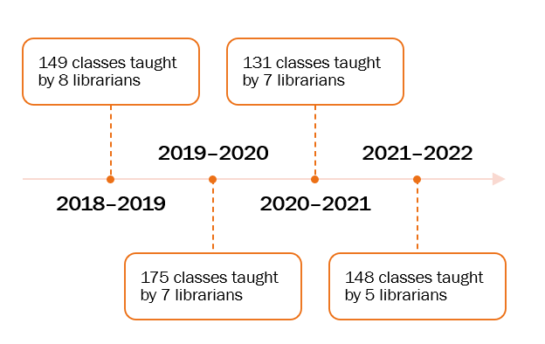a series of library workshops for education majors

While the number of classes have remained consistent, the number of librarians teaching the classes has consistently declined.

The audience for research instruction session is primarily Freshmen, with equal numbers of sophomores and juniors and a small number of seniors and graduate students.

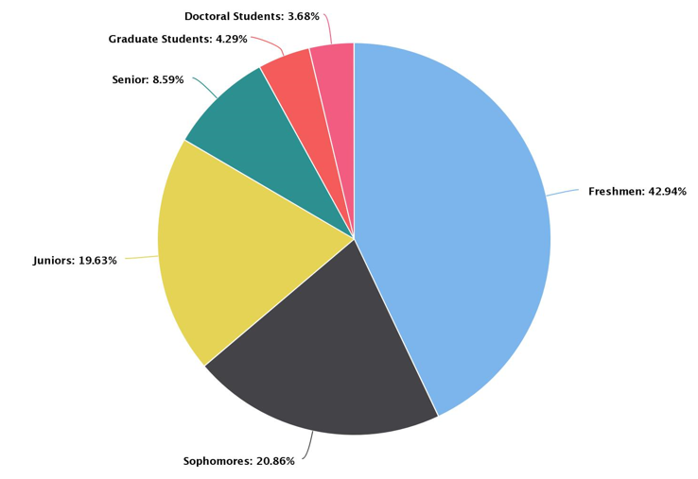

**Collections**

Major projects in the library’s collections this year include:

* Regular maintenance and troubleshooting of the library’s e-resources to ensure continued access.
* Reviewed and deaccessioned materials in these Library of Congress call number sections: business, history, language and literature, library science, general works, psychology, and medicine/nursing collection Support of the deaccessioning project
* Ordering and cataloging 883 new books and 192 new DVDs.
* Improving the public catalog display for print serials

**University Archives & Special Collections**

*Genna Duplisea, University Archivist and Special Collections Librarian*

The university’s 75th anniversary, coming in September 2022, loomed large over activities this year. University Archives and Special Collections (UASC) continued its efforts, begun at the time of the 70th anniversary, to digitize and make accessible more of the university’s records. Additionally, archivist Genna Duplisea contributed both research assistance and written articles to books being written about the university’s history and heritage.

**Archives Collections Management, Digitization, and Core Operations**

New accessions: 11 archives accessions and 1 Special Collections accessions, spanning around ~13 linear feet, and several volumes/objects.We processed 8.04 linear feet of materials, which was less than last year.

UASC sought to improve discoverability and reference services by providing additional guides to archival collections and digitized collections. New finding aids and inventories are as follows:

* Dennis Riley papers on Senator Claiborne Pell: <https://www.riamco.org/render?eadid=US-RNSRU-SP_19>
* Brother Eugene Lappin papers: <https://www.riamco.org/render?eadid=US-RNSRU-RG21.8>

UASC continued expanding digital collections this year:

* AV Collection: <https://library.artstor.org/#/collection/100330907>
* New scans <http://digitalcomons.salve.edu/student-newspapers>
* Arboretum digital collection: <https://library.artstor.org/#/collection/100194587>

UASC contracted long-time volunteer Michaela Sheerar for two projects:

* Processing the papers of Sister Sheila Megley (<https://www.riamco.org/render?eadid=US-RNSRU-RG6.1.9>)
* Creating ArchivesSpace records for oral histories: (<https://salvearchives.libraryhost.com/resources/salve_regina_memory>).

Poulin Archives Fellow Kayla Conde ’23 worked remotely to describe Mother Mary Matthew Doyle’s papers, now online at <https://www.jstor.org/site/salve-regina-university/doyle-papers/>. She also started describing the Mother Mary Hilda Miley papers, which are being scanned by work-study Geovanna Deoliveira ’24.

**Archives Academic Support**

Employing students continued to be a key part of the UASC academic program. Fall semester work-study Grace Parenti ’22 used her experience working with antique textiles to inventory the Goelet family linens, among other projects, and the library hired her as a contractor in summer 2022 to curate an exhibit for the 75th anniversary. For the spring semester, UASC hired Geovanna DeOliveira ’24 as a work-study and Kayla Conde ’23 as Poulin Archives Fellow.

UASC has published the following new bios or historical notes, a collaborative effort between Genna, Michaela, and summer work-study Ainsley Henderson ‘23:

* Sister Marianne Postiglione: <https://salvearchives.libraryhost.com/agents/postiglione_marianne>
* Sister Sheila Megley: <https://salvearchives.libraryhost.com/agents/megley_sheila_dr>
* Chateau-sur-Mer: <https://salvearchives.libraryhost.com/agents/chateau-sur-mer_newport_ri>

Student workers continued adding to the Press Releases collection: <http://digitalcommons.salve.edu/releases>

**Archives Outreach & Community Engagement**

Archives displays:

* *The Rubáiyát of Omar Khayyáam*
* *Dreaming in Green*
* *Having a Field Day*

UASC provided support for 75th anniversary research, particularly the written history to be written by Dr. John Quinn. Genna and the archives work-studies provided research assistance to two faculty members and several of the writers working on the *Muse & Mercy* book for the university’s 75th anniversary. Genna also wrote two entries for the book: one on the Salve Regina College Guild silver and another on the René Bouché portrait of Noreen Stonor Drexel. UASC was also part of meetings and conversations held by the 75th anniversary committee.

**Archives Reference & Usage Statistics**

Use of the Archives’ materials and services has increased dramatically, surpassing pre-pandemic reference/research inquiries.

* **110** reference requests or questions regarding University Archives and Special Collections materials or services: 40 faculty, 28 staff, 16 students, 11 alum, 15 public
* Compare to **36** requests in 2020-2021 and **71** requests in 2019-2020

*Digital Commons – Archives materials only*

Usage of the Archives & Special Collections materials in Digital Commons decreased between July 1, 2021 and June 30, 2022:

* Downloads: 20,479 (33,338 last year)
* Media streams: 191 (350 last year)
* Metadata page hits: 11,416 (9,730 last year)

*JSTOR Forum/Artstor Library (as of June 17, 2021)*

Usage of UASC materials published to Artstor:

* Salve Regina University Archives Photographs: 349 views
* Salve Regina University Property and Architecture Images: 455 views
* Johannes von Gumppenberg Digital Collection: 2083 views
* South Kingstown Colonial Records: 299 views
* Salve Regina University Archives Audiovisual Collection: 43 views
* Salve Regina University Arboretum: 62
* Nature Cabinet collection: 59 views
* Mother Mary Matthew Doyle Papers: 11 views
* Sisters of Mercy at Salve Regina: 14 views
* Student Unrest at Salve Regina: 98 views
* Winslow Family Papers: 101 views